V A X T R A C K
TECHNICAL SPECIFICATION DOCUMENT
VaxTrack Vaccination Management Platform
A ground-up technical reference to the VaxTrack v2.0.0 codebase — architecture, technology stack, backend and frontend structure, authentication design, every module and endpoint, the data model, and engineering conventions — written for engineers joining the project at any experience level.

DOCUMENT VERSION 1.0.0
RELEASE DATE 11 July 2026
STATUS Draft — Pending Engineering Review
CLASSIFICATION Confidential — Internal Use
PREPARED BY VaxTrack Engineering
COVERS Backend v2.0.0 / Frontend v2.0.0

This document is prepared for engineering review. It is a first draft — contents, terminology, and structure are expected to change following review feedback from the delivery lead and engineering team.

Document Control

Revision History
VERSION | DATE | AUTHOR | DESCRIPTION
1.0.0 | 2026-07-11 | VaxTrack Engineering | Initial draft of the Technical Specification Document for backend v2.0.0 / frontend v2.0.0 — architecture, technology stack, project structure, authentication design, per-module endpoint reference (67 endpoints across 6 controllers), data model, frontend structure, error handling, configuration, and engineering conventions.

Distribution List
NAME / GROUP | ROLE | PURPOSE OF REVIEW
Delivery Lead | Approver | Confirm technical scope and depth are fit for onboarding new engineers.
Engineering Team | Reviewer | Verify technical accuracy against the live codebase.
QA / Test Lead | Reviewer | Use as the technical basis for test design (endpoints, auth rules, data shapes).
New Joiners (0-5 yrs experience) | Reader | Primary onboarding reference for how the system is built.

Related Documents
DOCUMENT | RELATIONSHIP
VaxTrack — Functional Specification Document | Companion document — business requirements, roles, workflows, and business-level system diagrams. Read first for the "what and why"; this document covers the "how".
VaxTrack API Contracts (Bruno collections) | Machine-usable request/response contracts for every endpoint referenced in this document — one folder per module.
VaxTrack SQL Reference Scripts | Seed data, read, and truncate scripts — useful alongside Section 8 (Data Model).
VaxTrack — Test Cases Document | Companion document — test case catalogue (planned).
How to read this document — Sections 1-4 build up the big picture (purpose, architecture, tech stack, backend project layout). Sections 5-7 go deep on authentication and each of the six functional modules, endpoint by endpoint. Section 8 covers the data model and how the schema evolved. Section 9 covers the Angular frontend. Sections 10-14 cover error handling, configuration, engineering conventions, and a glossary for anyone new to these terms. If you only have twenty minutes, read Sections 2, 4, and 6 — they cover architecture, backend layering, and authentication, which unlock everything else.

Table of Contents
1. Introduction & Purpose
2. Architecture Overview
3. Technology Stack
4. Backend Project Structure
5. Authentication & Authorization
6. Module Reference — Auth
7. Module Reference — User
8. Module Reference — Hospital
9. Module Reference — Booking
10. Module Reference — UserRoleMapping
11. Module Reference — Notification
12. Data Model
13. Frontend Architecture
14. Error Handling & Custom Exceptions
15. Configuration & Environments
16. Engineering Conventions
17. Glossary
18. Appendix — Diagram Index

1. Introduction & Purpose

1.1 Purpose
This Technical Specification Document (TSD) explains how VaxTrack backend v2.0.0 (and its companion frontend v2.0.0) is actually built: the architecture, the technology choices, the project layout, the authentication design, every module and its endpoints, the data model, and the engineering conventions used throughout the codebase. Where the Functional Specification Document (FSD) answers "what does the system do and why", this document answers "how is it built, and where do I find the code that does it".

1.2 Intended Audience
This document is written for a broad engineering audience — deliberately so, at the request of the project owner, so that a fresher with anywhere from zero to five years of experience can read it and understand the system without needing to ask a teammate to explain the basics first.
- Backend and frontend developers joining the project, at any experience level — this is the primary onboarding path into the codebase.
- QA / test engineers — to understand exact endpoint behaviour, auth rules, and data shapes when designing test cases.
- Tech leads — as a reference for architectural decisions and their rationale, and a baseline to check implementation drift against.
- Delivery managers — to understand system scope and complexity at a level detailed enough to plan work, without needing to read the source code directly.

1.3 How to Read This Document
Terms that name a specific class, endpoint route, field, or file in the codebase are set in monospace, like this:
BookingService.CreateBookingAsync(CreateBookingRequestDto, callerUserUid)
This lets you distinguish an exact, greppable identifier from a plain-English description of what it does. Every endpoint table in Sections 6-11 lists the HTTP method, the exact route, what it does, and its authorization requirement — you can use these tables as a checklist while reading the corresponding controller source file.
This is an explicit first draft. The intent is completeness and correctness over polish — expect another review pass and iteration once the engineering team and delivery lead have read it.

2. Architecture Overview

2.1 High-Level Component View
VaxTrack v2.0.0 is a classic three-tier web application: a single-page Angular application in the browser, talking over HTTPS to a stateless ASP.NET Core Web API, backed by a single Microsoft SQL Server database. There is no message queue, no separate microservice, and no external system dependency beyond outbound SMTP for email (see Section 15) — the entire system fits in three moving parts.
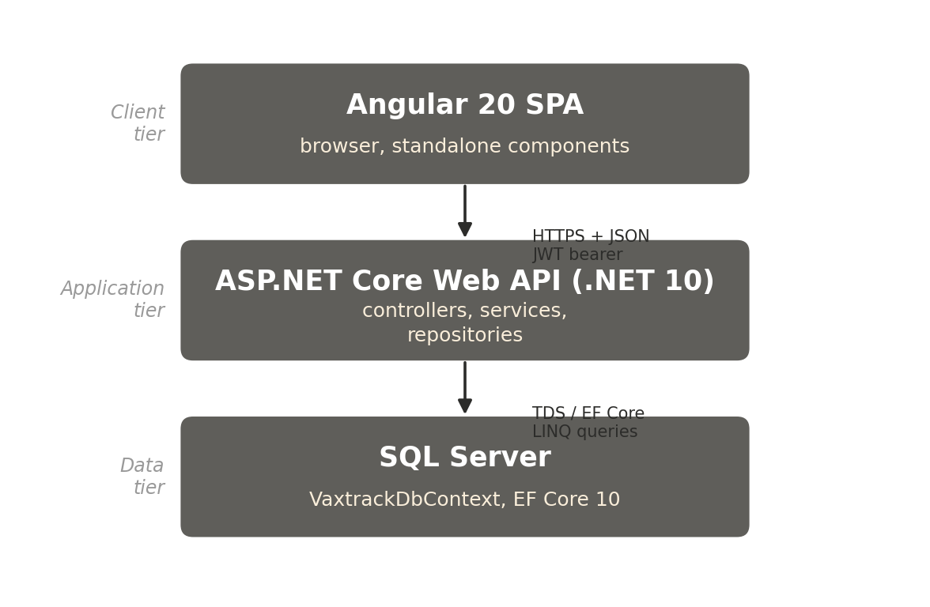
Figure 1. High-level component view — client, application, and data tiers.

2.2 Request Lifecycle
A typical authenticated request follows this path end to end:
- The Angular app builds an HTTP request. Its auth.interceptor (Section 13.4) attaches the caller's JWT as an Authorization: Bearer header, if one is present in local storage.
- The request reaches ASP.NET Core's middleware pipeline (registered in Program.cs — see Section 4.3). CORS is checked, then app.UseAuthentication() validates the JWT's signature, issuer, audience, and lifetime, and (via a custom OnTokenValidated hook) checks it hasn't been revoked and the account is still active.
- app.UseAuthorization() then evaluates any [Authorize] / [Authorize(Roles="admin")] attribute on the matched controller action.
- The matched controller action extracts the caller's identity (CallerUserUid, CallerIsAdmin — read from JWT claims) and calls the corresponding service method, passing the request DTO plus caller identity.
- The service applies business rules and — where the action targets a specific record — an ownership or scoped-role check, then calls one or more repository methods.
- The repository executes the actual EF Core query or command against VaxtrackDbContext, which SQL Server executes.
- The result flows back up: repository -> service -> controller, which wraps it in an ActionResult and serializes it to JSON.

2.3 Why API-First + SPA (and the Evolution from v1)
VaxTrack's earlier iterations (v1_backend, v1.0.0 through v1.3.0, retained in the repository for history) were built as a single ASP.NET Core MVC application with server-rendered Razor views and a SQLite database. That architecture tightly coupled the UI to the backend process — every page was rendered server-side, there was no separately deployable frontend, and there was no formal API surface for a future mobile client or third-party integration.
v2.0.0 is a deliberate API-first rewrite: the backend exposes nothing but a JSON REST API (documented via OpenAPI and mirrored as Bruno-compatible request collections), and the Angular SPA is a fully independent consumer of that API — it could be swapped for a mobile app or a different frontend framework without touching a single line of backend code. This also enabled a cleaner separation of concerns: every business rule and every authorization check now lives exclusively in the backend service layer, so the API is safe to call directly (e.g. from Bruno or a future mobile client) without relying on the frontend to enforce anything.
v1_backend is not covered in depth in this document — it is retained in the repository purely as historical context. All active development targets v2_backend/v2.0.0 and v2_frontend/v2.0.0.

3. Technology Stack
The table below is the authoritative technology snapshot for backend v2.0.0 and frontend v2.0.0, taken directly from the project's own README.
LAYER | TECHNOLOGY
Backend runtime & framework | ASP.NET Core Web API (.NET 10), C# 13
Data access | Entity Framework Core 10 over Microsoft SQL Server
Authentication | JWT Bearer (HMAC-SHA256) with server-side revocation
Password hashing | BCrypt.Net-Next
Logging | Serilog (console + rolling file sinks)
Frontend framework | Angular 20 (standalone components) + TailwindCSS
API documentation | ASP.NET Core OpenAPI, plus Bruno-compatible API contracts

3.1 Notes on Key Choices
- JWT with server-side revocation — a plain JWT is stateless by design (no server lookup needed to validate it), which is fast but means there is normally no way to "log out" early. VaxTrack adds a small SQL-backed blacklist (RevokedTokens) checked on every request, giving the speed of stateless JWTs with the safety of being able to revoke one immediately. See Section 5.3.
- BCrypt over a faster hash — BCrypt is deliberately slow and includes a per-hash salt, which is exactly what you want for password storage: it makes offline brute-forcing of a leaked hash table expensive. Plain text passwords are never persisted anywhere in the system.
- Angular standalone components (no NgModules) — matches current Angular guidance and keeps each feature self-contained, which mattered in practice as new features (admin screens, certificate verification, hospital lifecycle) were added incrementally without needing to wire up shared module declarations each time.

4. Backend Project Structure

4.1 Layered Architecture
The backend follows a strict layered architecture. Each layer only talks to the layer directly below it, and only through an interface, never a concrete class:
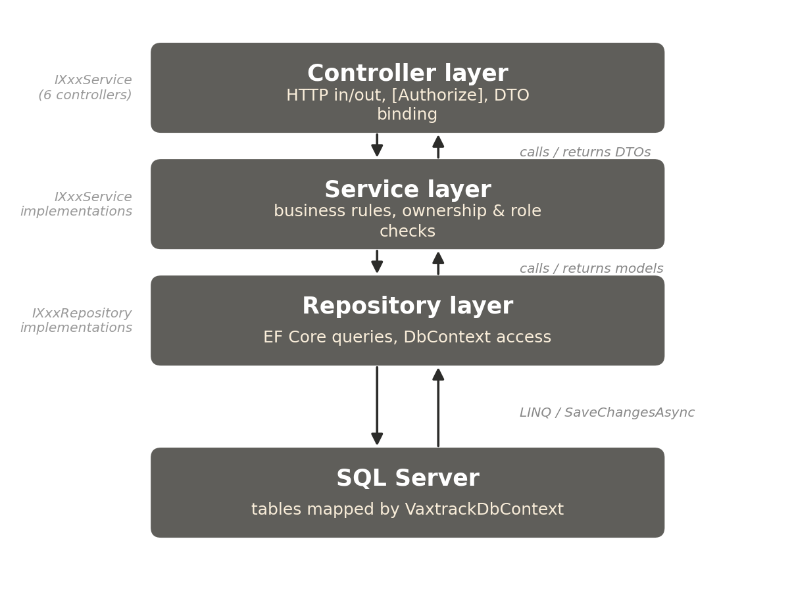
Figure 2. Backend layered architecture — Controller to Service to Repository to database.
- Controllers — receive the HTTP request, enforce [Authorize] declaratively, bind and validate the request DTO, extract caller identity from JWT claims, call exactly one service method, and translate the result (or a thrown exception) into an HTTP response. Controllers never talk to a repository or DbContext directly.
- Services — hold all business logic: validation beyond simple DTO annotations, ownership checks (does this caller own this record?), scoped-role checks (is this caller the hospital-admin for this specific hospital?), orchestration across multiple repositories, and audit-log/notification side effects. Every service implements an interface (IUserService, IBookingService, etc.) so it can be mocked in tests and so Program.cs can wire it up via dependency injection.
- Repositories — the only layer that talks to VaxtrackDbContext directly. Each repository is scoped to one entity or a closely related set of queries (e.g. IUserRepository, IBookingAuditLogRepository), and exposes intention-revealing async methods rather than a generic query interface.
Why layer it this way? It keeps business rules in exactly one place (services), makes the codebase testable (each layer can be tested or mocked independently through its interface), and means a change to how data is stored (e.g. switching an EF Core query) never requires touching a controller. This is a standard, widely-used pattern in production ASP.NET Core applications — freshers coming from any other layered backend framework (Spring Boot, Django, Rails) will recognise the shape immediately.

4.2 Folder-by-Folder Reference
FOLDER | CONTENTS
Controllers/ | 6 controllers — one per module (Auth, User, Hospital, Booking, UserRoleMapping, Notification). Thin — no business logic.
Dtos/ | Request/response contracts, one subfolder per module (e.g. AuthDtos, BookingDtos). DTOs never leak EF Core entity models to the API surface — this keeps the wire format stable even if the schema changes internally.
Interfaces/ | Service interfaces at the top level (IUserService, IBookingService, ...) and repository interfaces under RepositoryInterfaces/. Every service and repository implementation is registered against its interface in Program.cs.
Services/ | Business logic implementations — one class per module, plus EmailService for outbound mail.
Repositories/ | EF Core data-access implementations — one class per entity/concern (e.g. TokenBlacklistRepository, PasswordResetTokenRepository).
Models/ | EF Core entity classes — the tables. See Section 12 for the full entity list.
Exceptions/ | Custom exception types used to signal specific failure conditions up through the layers (e.g. AccountDisabledException — see Section 14).
Migrations/ | EF Core migration history — 20 migrations tracing the schema's evolution from initial create to the current shape. See Section 12.3.
Utilities/ | Small stateless helpers not tied to any one module — ID generation, GUID generation, age calculation (UtilityService).
wwwroot/uploads/ | Static file storage for uploaded profile pictures, served directly by the ASP.NET Core static file middleware.

4.3 Program.cs — Application Startup
Program.cs is the single composition root for the entire backend. A fresher reading it top to bottom sees, in order:
- Serilog configuration — a new timestamped log file is created on every app start, in addition to console output (see Section 16.1).
- A one-line fix that matters a lot in practice: JwtSecurityTokenHandler.DefaultInboundClaimTypeMap.Clear() plus options.MapInboundClaims = false on the JWT bearer handler. Without both of these, ASP.NET Core silently remaps short JWT claim names (sub, role) to long legacy URIs, which breaks every User.FindFirst(JwtRegisteredClaimNames.Sub) call in the controllers and every [Authorize(Roles="admin")] check. This is called out explicitly in code comments because it is an easy, non-obvious trap.
- JwtSettings and SmtpSettings are bound from configuration and registered as singletons, so any service can have them injected.
- JWT bearer authentication is configured with an OnTokenValidated event hook that performs the token-blacklist and account-status checks described in Section 5.3 — this is what makes logout and account-disable take effect immediately on an already-issued token, not just on the next login attempt.
- CORS (AllowAll policy — appropriate for local development, tightened per environment in a production deployment), EF Core's DbContext (SQL Server), and every repository/service pair are registered for dependency injection.
- The middleware pipeline is assembled in this exact order: HTTPS redirection, static files (for uploaded profile pictures, with a no-cache header so a re-uploaded picture doesn't stay stale in the browser), CORS, authentication, authorization, then controller routing.
- On startup, dbContext.Database.MigrateAsync() runs any pending EF Core migrations automatically — the database schema is always brought up to date before the app starts serving requests.

4.4 Route Convention
Every controller is versioned and namespaced identically:
[Route("/api/vaxtrack/v1/[controller]/[action]")]
[controller] resolves to the controller's name (e.g. user for UserController), and [action] resolves to the method name (e.g. createuserasync becomes createuser — ASP.NET Core strips the Async suffix and lower-cases it by convention). So CreateUserAsync in UserController is reachable at POST /api/vaxtrack/v1/user/createuser. This action-based routing (rather than one fixed verb per controller) is why the endpoint tables in Sections 6-11 list a distinct route per method rather than a RESTful resource path.

5. Authentication & Authorization
This is the section most worth reading carefully before touching any controller — every endpoint's behaviour depends on the identity and role model described here.

5.1 JWT Issuance
On a successful POST /api/vaxtrack/v1/auth/login, AuthService.LoginAsync verifies the supplied password against the stored BCrypt hash, then issues a JWT signed with HMAC-SHA256 using a symmetric key from JwtSettings. The token carries four claims that matter to every downstream check:
CLAIM | MEANING
sub | The caller's UserUid (GUID) — the identity every ownership check compares against, not the human-readable UserId.
role | "admin" if UserModel.UserRole is true, otherwise omitted. Backs [Authorize(Roles="admin")] and User.IsInRole("admin").
jti | A unique token ID, generated fresh per login. This is what gets stored in RevokedTokens on logout — never the full token string.
exp | Standard JWT expiry claim. Token lifetime is configured via JwtSettings.ExpiryMinutes (60 minutes by default).
RoleClaimType is explicitly set to "role" in Program.cs's TokenValidationParameters, and MapInboundClaims is set to false on the JWT bearer handler. Without both, ASP.NET Core's default claim-type remapping silently breaks role checks — see Section 4.3 for why this is called out.

5.2 Password Hashing
Passwords are hashed with BCrypt.Net-Next (BCrypt.HashPassword / BCrypt.Verify) and stored on UserCredentialsModel.PasswordHash — never on the UserModel itself (see Section 12.2 for why credentials are a separate table). Plain-text passwords are never persisted or logged anywhere in the system.

5.3 Server-Side Revocation
A JWT is stateless by nature — once issued, it remains valid until it expires, with no built-in way to force it invalid early. VaxTrack layers two independent revocation mechanisms on top, both checked on every authenticated request via a JwtBearerEvents.OnTokenValidated hook in Program.cs:
- Explicit logout — POST /api/vaxtrack/v1/auth/logout reads the token's jti and exp claims and inserts a row into RevokedTokens. Every subsequent request presenting that same token is checked against this table (ITokenBlacklistRepository.IsRevokedAsync(jti)) and rejected with 401 if found — even though the token's signature and expiry are still technically valid.
- Account-disable takes effect immediately — the same hook independently looks up the caller's current UserModel.Status on every request. If an admin disables a user mid-session, that user's already-issued, not-yet-expired token stops working on their very next request — the disable does not wait for the token to expire or for the user to log in again.
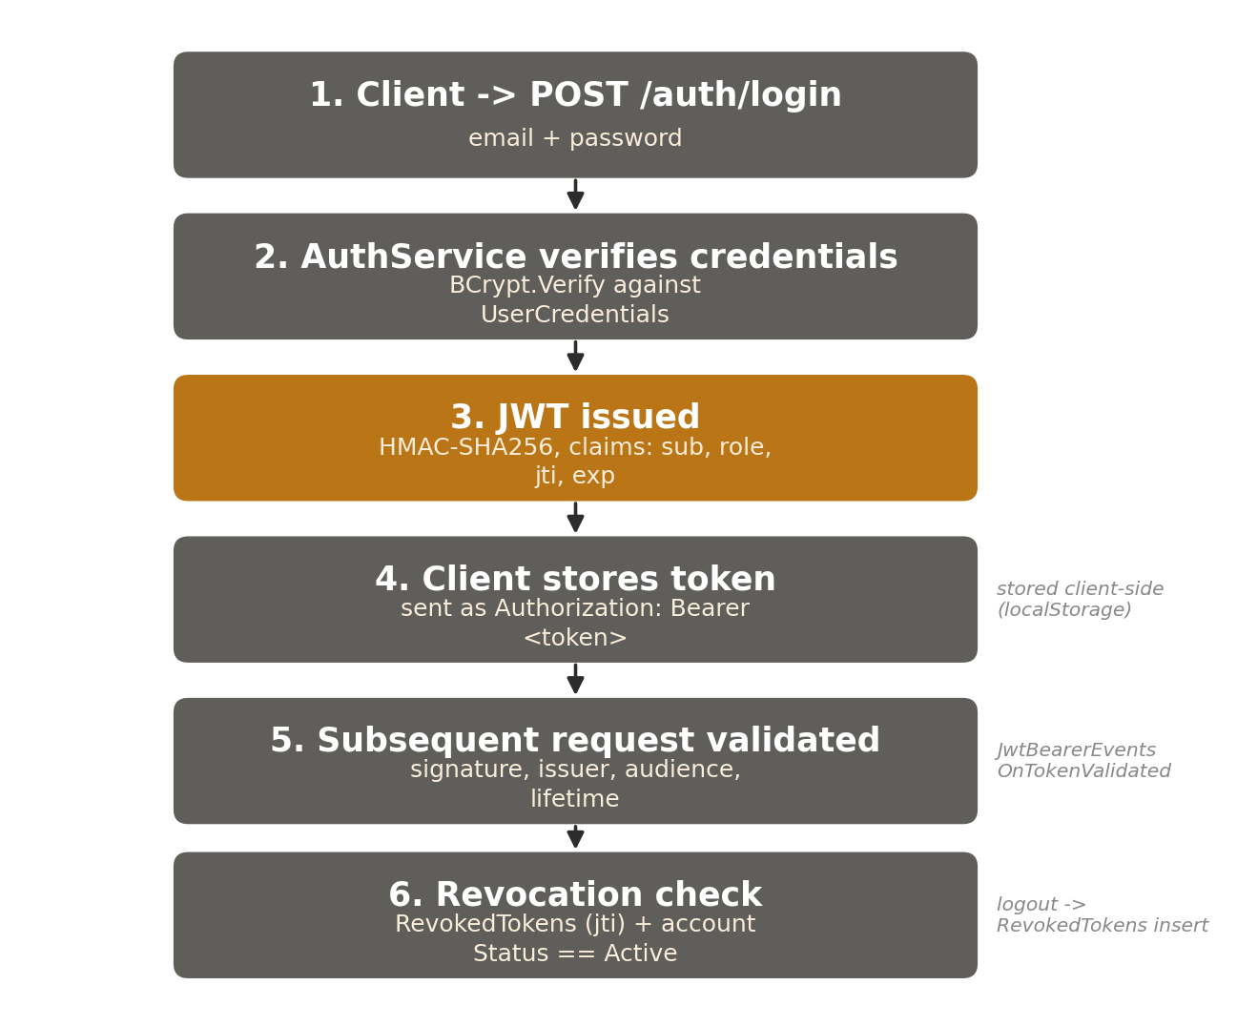
Figure 3. Login through subsequent-request validation, including the revocation check.

5.4 Three-Tier Role Model
VaxTrack layers two independent role mechanisms, described functionally in the companion FSD and enforced technically as follows:
ROLE | STORAGE | ENFORCEMENT
Normal user | Default — UserModel.UserRole = false | No special attribute; ownership checks inside each service compare the record's owning UserUid to the caller's sub claim.
Hospital admin | A row in UserRoleMappingModel with RoleTag = "hospital-admin" and ContextId = the specific HospitalId | Not encoded in the JWT. Checked at runtime inside the service layer via IUserRoleMappingRepository.IsUserInRoleAsync(callerUserUid, "hospital-admin", hospitalId) — scoped to the exact hospital being acted on.
Platform admin | UserModel.UserRole = true | Baked into the JWT as the role=admin claim. Enforced declaratively with [Authorize(Roles="admin")] at the controller level, and unconditionally satisfies any scoped-role check in the service layer without a database lookup.

5.5 Ownership & Scoped-Role Enforcement Pattern
Nearly every non-admin-only endpoint follows the same pattern, established across the codebase for consistency:
- 1. The controller reads CallerUserUid (from the sub claim) and CallerIsAdmin (from User.IsInRole("admin")) and passes both into the service method — never trusting a UserUid supplied in the request body for identity purposes.
- 2. The service fetches the target record, then checks record.OwnerUid == callerUserUid || callerIsAdmin (ownership) or, for hospital-scoped actions, the role-mapping check from 5.4.
- 3. On failure, the service throws UnauthorizedAccessException. The controller catches this specific exception and returns 403 Forbid() — distinct from a 401, which means "not authenticated at all".
This pattern was retrofitted deliberately (see the 2026-06-25 engineering log) after an initial gap: early endpoints trusted a client-supplied UserId to decide whose data to return or modify, which meant any authenticated user could view or cancel another user's booking simply by guessing their ID. Every endpoint in Sections 6-11 that says "ownership checked" or "scoped check" in its notes was hardened by this pass.

5.6 Client-Side Enforcement (Angular)
Route guards (authGuard, adminGuard, hospitalAdminOrAdminGuard — Section 13.3) prevent an unauthenticated or under-privileged user from even loading a route in the SPA. This is a UX convenience only — it improves the experience by not rendering a screen the user cannot use, but it is never the actual security boundary. Every rule enforced by a guard is independently re-enforced server-side per Sections 5.4 and 5.5; a request crafted directly against the API (bypassing the Angular app entirely, e.g. via Bruno) is subject to exactly the same checks.

6. Module Reference — Auth
Controller: AuthController.cs | Service: AuthService.cs / IAuthService.cs | Base route: /api/vaxtrack/v1/auth
Handles login, logout, and every self-service path back into the system for a user who cannot currently log in (forgotten password, disabled account).

6.1 Endpoints (5)
METHOD | ROUTE | PURPOSE | AUTH
POST | /auth/login | Authenticate with email + password, issue a JWT. | AllowAnonymous
POST | /auth/logout | Revoke the caller's current token (adds its jti to the blacklist). | Authorize
POST | /auth/forgotpassword | Step 1 of password recovery — request a reset token by email. | AllowAnonymous
POST | /auth/resetforgottenpassword | Step 2 of password recovery — consume the token, set a new password. | AllowAnonymous
POST | /auth/requestaccountreactivation | The only path back for a disabled account, since login itself is blocked. | AllowAnonymous

6.2 Key DTO Shapes
LoginRequestDto -> LoginResponseDto — request carries Email, Password; response carries Token, ExpiresAt, UserId, UserUid, UserName, Email, UserRole (bool — true means platform admin). The frontend stores this whole response, not just the token, so it can branch on UserRole immediately without a second round trip.
ForgotPasswordResponseDto carries Message, plus ResetToken and ExpiresAt which are always null today — the field exists for frontend model compatibility from an earlier development stage where the token was returned directly (before IEmailService existed); the token is now emailed to the user and never appears in the response body.

6.3 Business Logic Worth Flagging
- Timing-safe disabled-account check — AccountDisabledException is thrown only after the password has already been verified. If the check ran before password verification, a wrong-password guess against a disabled account's email would leak whether that account exists and is disabled — a classic enumeration side-channel. See Section 14 for the exception itself.
- Email enumeration resistance — ForgotPasswordAsync always returns the same generic message whether or not the supplied email is registered, so an attacker cannot use the endpoint to discover valid accounts.
- Single-use, short-lived reset tokens — a PasswordResetTokenModel row is created with a 15-minute expiry; IsUsed is set before the password write completes, closing a race-condition window where the same token could be replayed twice.
- Reactivation is the only door back in — once UserModel.Status is anything other than "Active", login is fully blocked, so RequestAccountReactivationAsync must be reachable without authentication. It writes a UserRequestModel (RequestType = "AccountReactivation") that a platform admin resolves via the User module's ApproveUserReactivationAsync / RejectUserReactivationAsync endpoints (Section 7).

6.4 Related Entities
UserCredentialsModel (email + password hash lookup), RevokedTokenModel (logout blacklist), PasswordResetTokenModel (forgot-password flow), UserRequestModel (reactivation requests).

7. Module Reference — User
Controller: UserController.cs | Service: UserService.cs / IUserService.cs | Base route: /api/vaxtrack/v1/user
Owns registration, profile self-service, the full user lifecycle (disable/reactivate/promote/demote), and account deletion — both self-service and admin-initiated.

7.1 Endpoints (16)
METHOD | ROUTE | PURPOSE | AUTH
POST | /user/createuser | Register a new user account. | AllowAnonymous
PUT | /user/updateuser | Update own profile fields (name, phone, address, etc.). | Authorize, ownership
PUT | /user/updateemail | Change own email — requires current password unless caller is admin. | Authorize, ownership
PUT | /user/changepassword | Change own password — requires current password unless caller is admin. | Authorize, ownership
POST | /user/uploadprofilepicture | Multipart upload of a profile picture. | Authorize, ownership
PUT | /user/removeprofilepicture/{userId} | Remove the current profile picture. | Authorize, ownership
GET | /user/getallusers | List every user, unpaged. | admin
GET | /user/getuserspaged | Filterable, sortable, paginated user listing (Users Management screen). | admin
GET | /user/getuserprofiledata/{userId} | Fetch one user's profile. | Authorize, ownership
DELETE | /user/deletemyaccount | Self-delete — identified from the JWT, requires password re-entry. | Authorize
DELETE | /user/deleteuser/{userId} | Delete any user account. | admin
PUT | /user/disableuser/{userId} | Disable an account — reason required. | admin
PUT | /user/approveuserreactivation/{userId} | Approve a pending reactivation request. | admin
PUT | /user/rejectuserreactivation/{userId} | Reject a pending reactivation request. | admin
PUT | /user/promotetoadmin/{userId} | Grant platform-admin (UserModel.UserRole = true). | admin
PUT | /user/demotefromadmin/{userId} | Revoke platform-admin. | admin

7.2 Key DTO Shapes
CreateUserRequestDto — FirstName, LastName, UserBirthdate, UserGender, UserPhone (10-digit, regex-validated), UserAddress, UserPinCode (6-digit), Email, Password (min. 8 characters).
UserProfileDataDto — the read model returned by GetUserProfileDataAsync and used across GetAllUsersAsync/GetUsersPagedAsync. Includes IsHospitalAdmin (bool, server-computed from role mappings), VaccinationStatus, Status/StatusComment (lifecycle), alongside the base profile fields. UserUid is included here but never exposed for cross-user lookups — only the caller's own profile or an admin's request returns it.
PagedUsersResponseDto — Items (List<UserProfileDataDto>), TotalCount, Page, PageSize. GetUsersPagedAsync accepts filter query params (name, phone, userId, userUid, role, vaccinationStatus), plus sortBy/sortDir and page/pageSize — this backs the admin Users Management screen instead of the unpaged GetAllUsersAsync.

7.3 Business Logic Worth Flagging
- Duplicate-email guard — CreateUserAsync checks GetCredentialsByEmailAsync before saving. There is deliberately no database-level unique constraint on email, because the soft-delete design (7.3 below) keeps a deleted account's email on record for audit — a DB constraint would conflict with that. The uniqueness check is service-layer only, filtered to active (non-deleted) rows.
- Admin bypass on credential changes — UpdateEmailAsync and ChangePasswordAsync require CurrentPassword from a non-admin caller (proving they still control the account) but skip that check for an admin caller — this is the deliberate support/account-recovery override path.
- Self-delete cascade — DeleteMyAccountAsync and DeleteUserAsync both route through a shared private helper, ExecuteUserDeleteCascadeAsync, which: soft-deletes the user profile; soft-deletes all their bookings and releases any reserved hospital slots back to availability; revokes all their role mappings; and soft-deletes their credentials row, explicitly clearing PasswordHash (a deleted account's hash has no legitimate further use, and keeping it is a pure liability if the database is ever compromised).
- Double-gated login block after deletion — a soft-deleted account cannot log in because two independent lookups both filter it out: GetCredentialsByEmailAsync (excludes IsDeleted credentials) and GetUserDetailsByUserUidAsync (excludes IsDeleted users). Either gate alone would be sufficient; both exist for defence in depth.

7.4 Related Audit-Log Behaviour
Every lifecycle transition (disable, reactivation request/approve/reject) writes a UserAuditLogModel row: UserId, ActionType ("Disabled" | "ReactivationRequested" | "ReactivationApproved" | "ReactivationRejected"), ActorUserUid, ActorRole, optional Comment, CreatedAt. This is separate from the UserRequestModel table, which tracks the pending-request queue itself rather than the historical trail.

8. Module Reference — Hospital
Controller: HospitalController.cs | Service: HospitalService.cs / IHospitalService.cs | Base route: /api/vaxtrack/v1/hospital
Owns the hospital directory, slot capacity, and the full hospital lifecycle: disable, reactivation request/approve/reject, and a two-party unregister flow.

8.1 Endpoints (15)
METHOD | ROUTE | PURPOSE | AUTH
POST | /hospital/createhospital | Register a new hospital. | admin
PUT | /hospital/updatehospital | Update contact details (address, pin code, phone, email). | admin or scoped hospital-admin
PUT | /hospital/updatetotalslots/{hospitalId}/{totalSlots} | Change total slot capacity. | admin or scoped hospital-admin
PUT | /hospital/updateavailableslots/{hospitalId}/{slotsToUpdate} | Adjust live available slots. | admin or scoped hospital-admin*
GET | /hospital/gethospitalbyid/{hospitalId} | Fetch one hospital's profile. | Authorize
GET | /hospital/getallhospitals | List every hospital. | Authorize
PUT | /hospital/disablehospital/{hospitalId} | Disable a hospital — reason required. | admin
PUT | /hospital/requestreactivation/{hospitalId} | The hospital's own hospital-admin asks to be re-enabled. | Authorize, scoped
PUT | /hospital/approvereactivation/{hospitalId} | Approve a pending reactivation. | admin
PUT | /hospital/rejectreactivation/{hospitalId} | Reject a pending reactivation. | admin
PUT | /hospital/requestunregister/{hospitalId} | Start the two-party unregister flow — reason required. | admin
PUT | /hospital/withdrawunregisterrequest/{hospitalId} | Admin backs out of a pending unregister. | admin
PUT | /hospital/declineunregisterrequest/{hospitalId} | Hospital-admin pushes back on a pending unregister. | Authorize, scoped
PUT | /hospital/authorizeunregister/{hospitalId} | Second-party confirmation (password re-entry) that finalizes the unregister. | Authorize, scoped
GET | /hospital/gethospitalaudittrail/{hospitalId} | Full lifecycle history for one hospital. | Authorize, scoped
* UpdateAvailableSlotsAsync's callerIsAdmin parameter defaults to true so BookingService can call it internally (slot reservation/release on create, cancel, and delete) without going through the controller's real authorization path. Controller-originated calls always pass the real caller's identity and role.

8.2 Key DTO Shapes
HospitalProfileDataDto — HospitalId, HospitalUid, HospitalName, HospitalAddress, HospitalPinCode, HospitalPhoneNumber, HospitalEmail, TotalSlots, SlotsAvailable, Status ("Active" | "Disabled" | "PendingReactivation" | "PendingUnregistration" | "Unregistered"), StatusComment, HospitalAdminCount (server-computed), RegisteredDate, UpdatedDate.
CreateHospitalRequestDto is deliberately minimal — just HospitalName. Address, phone, email, and slot capacity are filled in afterward via UpdateHospitalAsync / UpdateTotalSlotsAsync, which lets a newly-registered hospital's own hospital-admin complete their own profile once assigned.
AuthorizeUnregisterRequestDto — Password + optional Comment. This is the payload for the second-party confirmation step described below.

8.3 Business Logic Worth Flagging
- Status-driven lifecycle, not a boolean — HospitalModel.Status is a string state machine (Active -> Disabled -> PendingReactivation -> Active, or Active -> PendingUnregistration -> Unregistered), not a simple IsActive flag — this is what lets the frontend show the right set of action buttons for the hospital's current state (Section 13).
- Two-party confirmation before permanent removal — a platform admin can only request an unregister (RequestUnregisterAsync). The hospital's own hospital-admin (or the platform admin themselves, if no hospital-admin is assigned) must independently re-enter their own login password via AuthorizeUnregisterAsync before the unregister actually finalizes. This mirrors the pattern of requiring a second, freshly-authenticated confirmation before an irreversible action — the same reasoning behind requiring current-password re-entry for self-account-deletion in the User module.
- Scoped-role gap fix — UpdateHospitalAsync, UpdateTotalSlotsAsync, and UpdateAvailableSlotsAsync were originally admin-only. The 2026-06-25 engineering pass extended them to a hospital's own hospital-admin, checked via IUserRoleMappingRepository.IsUserInRoleAsync(callerUserUid, "hospital-admin", hospitalId) — before this fix, the hospital-admin role existed in the database but was entirely inert.

8.4 Related Audit-Log Behaviour
Every lifecycle transition writes a HospitalAuditLogModel row — ActionType is one of "Disabled", "ReactivationRequested", "ReactivationApproved", "ReactivationRejected", "UnregisterRequested", "UnregisterWithdrawn", "UnregisterDeclined", "Unregistered" — retrievable via GetHospitalAuditTrailAsync.

9. Module Reference — Booking
Controller: BookingController.cs | Service: BookingService.cs / IBookingService.cs | Base route: /api/vaxtrack/v1/booking
The largest and most business-rule-dense module. Owns the full two-dose booking lifecycle: create, approve/reject, cancel, edit, rebook, and certificate issuance.

9.1 Endpoints (18)
METHOD | ROUTE | PURPOSE | AUTH
GET | /booking/getcertificate/{bookingId} | Public certificate lookup by bookingId. | AllowAnonymous
POST | /booking/createbooking | Book Dose 1 for the caller. | Authorize, ownership
PUT | /booking/updatebooking | Admin override of all booking fields. | admin
PUT | /booking/bookdose2 | Book Dose 2 for an existing booking. | Authorize, ownership
PUT | /booking/editbooking | Move an unapproved dose to a new hospital/date. | Authorize, ownership
PUT | /booking/rebookdose1 | Re-create Dose 1 after it was cancelled/rejected. | Authorize, ownership
PUT | /booking/approvebookings/{bookingId} | Approve the pending dose. | admin or scoped hospital-admin
PUT | /booking/cancelbookings/{bookingId} | User-initiated cancel. | Authorize, ownership
PUT | /booking/rejectbookings/{bookingId} | Admin/hospital-admin-initiated rejection. | admin or scoped hospital-admin
GET | /booking/getbookingaudittrail/{bookingId} | Full action history for one booking. | Authorize, ownership
GET | /booking/getactionablebookings | Bookings awaiting the caller's action. | Authorize
GET | /booking/getbookingbybookingid/{bookingId} | Fetch one booking. | Authorize, ownership
GET | /booking/getbookingsbyuserid/{userId} | Fetch one user's bookings. | Authorize, ownership
GET | /booking/getbookingsbyhospitalid/{hospitalId} | All bookings at a hospital. | Authorize
GET | /booking/getallbookings | Every booking, platform-wide. | admin
GET | /booking/getnextavailableslot/{hospitalId}/{date} | Preview the slot a new booking would receive. | Authorize
GET | /booking/isbookingexists/{bookingId} | Existence check. | Authorize
DELETE | /booking/deletebooking/{bookingId} | Hard admin delete. | admin

9.2 Key DTO Shapes
CreateBookingRequestDto — UserUid, Dose1RequestedDateTime, Dose1HospitalUid. BookDose2RequestDto mirrors this for Dose 2, adding BookingId.
BookingProfileDataDto — the primary read model, extended in the 2026-07-08 pass with server-computed display fields so the frontend stops re-deriving status from raw booleans: Dose1DisplayStatus/Dose2DisplayStatus ("Pending" | "Completed" | "Cancelled" | "Rejected" | "NotBooked"), VaccinationDisplayStatus ("NotVaccinated" | "Pending" | "PartiallyVaccinated" | "Vaccinated" | "Rejected"), and Dose1HospitalAdminEmails/Dose2HospitalAdminEmails (comma-joined) for contact-info display.
CertificateDto — the deliberately restricted public shape: BookingId, BeneficiaryName, BeneficiaryAge, BeneficiaryGender, Dose1HospitalName, Dose1CompletedDate, Dose2HospitalName, Dose2CompletedDate, VaccinationCompletedDate — no email, phone, or address, matching how a real printed vaccination certificate would behave.

9.3 Business Logic Worth Flagging
- Cancel vs. Reject are tracked separately — CancelBookingsAsync (user-initiated) and RejectBookingAsync (admin/hospital-admin-initiated) are semantically distinct actions, each writing its own BookingAuditLogModel entry, even though both ultimately mark the dose as not-going-ahead — this distinction matters for reporting on hospital-side rejection rates versus user-side cancellations.
- Ownership resolved from the JWT, not the request body — BookDose2Async originally trusted a client-supplied UserUid in the DTO to decide ownership, which was exploitable by forging that field. It now validates against CallerUserUid from the JWT sub claim instead — the DTO field is retained for the request shape but is no longer trusted for authorization.
- Slot reservation and release — creating a booking reserves one slot at the target hospital (UpdateAvailableSlotsAsync internal call); cancelling, rejecting, or hard-deleting a booking releases it back. This is why UpdateAvailableSlotsAsync needs the internal-call bypass described in Section 8.1.
- UpdateBookingAsync is intentionally admin-only — it allows full field override, including dose-completion flags and timestamps. A regular user must never be able to mark their own dose "completed" — that would let anyone self-issue a certificate.
- GetActionableBookingsAsync is scope-safe by construction — for a hospital-admin, it returns only bookings pending at hospitals they manage; for a platform admin, every pending booking; for a caller with no hospital-admin assignment, an empty list — never an error, and never another hospital's data.

9.4 The Booking Lifecycle, Technically
Figure 4 traces the same end-to-end journey as the FSD's business-level version, but annotated with the controller, service method, and table touched at each step.
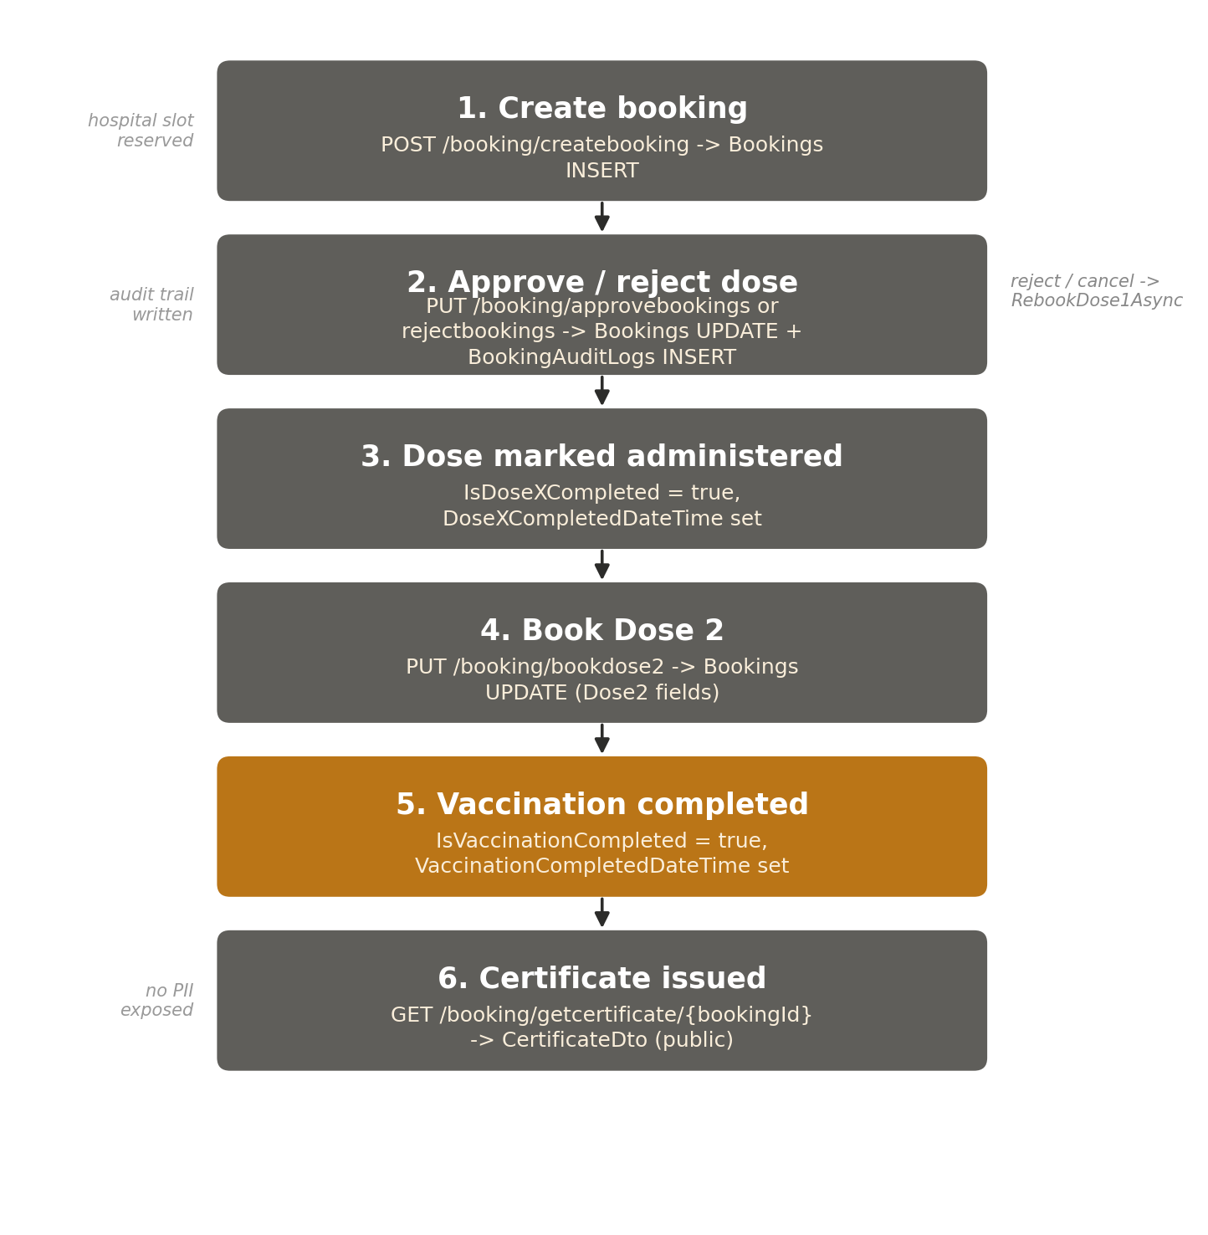
Figure 4. Booking lifecycle data flow — book, approve/reject, dose administered, certificate.

9.5 Related Entities & Audit-Log Behaviour
BookingModel (see full field list in Section 12.1) and BookingAuditLogModel — ActionType is one of "Dose1Booked", "Dose2Booked", "Approved", "Rejected", "Cancelled", "Rebooked", "Edited", each written by the corresponding service method alongside the field change itself, retrievable via GetBookingAuditTrailAsync.

10. Module Reference — UserRoleMapping
Controller: UserRoleMappingController.cs | Service: UserRoleMappingService.cs / IUserRoleMappingService.cs | Base route: /api/vaxtrack/v1/userrolemapping
Owns scoped role assignment (the hospital-admin mechanism described in Section 5.4) plus the self-service hospital-admin application flow.

10.1 Endpoints (9)
METHOD | ROUTE | PURPOSE | AUTH
POST | /userrolemapping/assignrole | Directly assign a scoped role to a user. | admin
DELETE | /userrolemapping/revokerole/{mappingId} | Revoke a role assignment. | admin
GET | /userrolemapping/getuserroles/{userUid} | List a user's own role assignments. | Authorize, self-or-admin
GET | /userrolemapping/getusersinrole/{roleTag} | List every user holding a given role (optionally scoped). | admin
GET | /userrolemapping/isuserinrole/{userUid}/{roleTag} | Check whether a user holds a role (optionally scoped). | Authorize, self-or-admin
POST | /userrolemapping/submithospitaladminapplication | Apply to manage a specific hospital. | Authorize
PUT | /userrolemapping/approvehospitaladminapplication/{requestId} | Approve an application — creates the role mapping. | admin
PUT | /userrolemapping/rejecthospitaladminapplication/{requestId} | Reject an application. | admin
GET | /userrolemapping/getpendingrequests | Admin's combined queue of pending requests. | admin

10.2 Key DTO Shapes
AssignRoleRequestDto — UserUid, RoleTag (e.g. "hospital-admin"), ContextId (empty string means a global/platform-wide role; a HospitalId scopes it to one hospital). This is the general-purpose mechanism — hospital-admin is the only role tag currently used by the product, but the schema does not hard-code it.
SubmitHospitalAdminApplicationRequestDto — HospitalId + optional Comment. UserRequestDto is the shared read shape for both request types this module and the User module create (RequestType = "AccountReactivation" or "HospitalAdminApplication"), including TargetHospitalId, Status, UserComment/AdminComment, and resolution metadata.

10.3 Business Logic Worth Flagging
- Role is never in the JWT — a scoped role (unlike the platform-admin flag) is not encoded in the token at all. GetUserRolesAsync exists specifically so the frontend can ask "what am I scoped to manage?" on page load / refresh, since there is no other way to recover this client-side (see AuthService.refreshRoleContext() in Section 13.4).
- ContextId convention — a HospitalId (the human-readable primary key) is used as ContextId, not HospitalUid, for consistency with how BookingModel.Dose1HospitalUid/Dose2HospitalUid are actually populated with HospitalId values despite the Uid naming — a naming inconsistency worth knowing about if you're reading the raw table data.
- Approval creates the mapping, not just the status — ApproveHospitalAdminApplicationAsync both flips the UserRequestModel.Status to "Approved" and inserts the actual UserRoleMappingModel row (RoleTag = "hospital-admin", ContextId = the applied-for HospitalId) — the applicant's elevated access takes effect the moment this endpoint returns, not on their next login.
- Soft-revoke — RevokeRoleAsync sets IsActive = false rather than deleting the row, preserving the audit record of who once held a role and when it was revoked.

10.4 Related Entities
UserRoleMappingModel (the role assignments themselves), UserRequestModel (the pending-request queue — shared with the User module's account-reactivation flow).

11. Module Reference — Notification
Controller: NotificationController.cs | Service: NotificationService.cs / INotificationService.cs | Base route: /api/vaxtrack/v1/notification
The newest module (added 2026-07-08 alongside hospital-admin applications). Delivers in-app notifications fired whenever another module's action needs the recipient's attention.

11.1 Endpoints (4)
METHOD | ROUTE | PURPOSE | AUTH
GET | /notification/getmynotifications | List the caller's notifications, newest first. | Authorize
GET | /notification/getunreadcount | Unread notification count (for a nav-bar badge). | Authorize
PUT | /notification/markasread/{id} | Mark one notification read. | Authorize, ownership
PUT | /notification/markallasread | Mark every one of the caller's notifications read. | Authorize

11.2 Key DTO Shape
NotificationDto — Id, Message, LinkPath (optional frontend deep-link, e.g. "/hospital", letting the UI route the user straight to the relevant screen on click), IsRead, CreatedAt.

11.3 Business Logic Worth Flagging
- Fire-and-forget, not transactional — notifications are created via NotifyAsync (one recipient) or NotifyAllAdminsAsync (broadcast to every platform admin), called from inside the Booking, Hospital, and UserRoleMapping services alongside their audit-log writes, whenever a booking is approved/rejected, a hospital's status changes, or a self-service application is resolved. A notification-write failure is not designed to roll back the underlying business action.
- Ownership on mark-as-read — MarkAsReadAsync checks the notification's RecipientUserUid against the caller before updating IsRead, throwing UnauthorizedAccessException otherwise — a user cannot mark another user's notification as read.

11.4 Related Entities
NotificationModel is the sole entity. It has no audit-log counterpart of its own — a notification is itself already a lightweight, timestamped record of "something happened that this user should know about".

12. Data Model

12.1 Entity List
Every entity below is a DbSet on VaxtrackDbContext (Program.cs), mapped 1:1 to a SQL Server table by EF Core. Primary keys in this system are deliberately split into two identifiers on the "main" entities: a short, human-readable, sortable Id used as the primary key and in URLs (e.g. CityCare-17-c4, generated by UtilityService.GenerateUniqueIdAsync), and a system Uid (GUID) used as the foreign key everywhere a stable, unguessable reference is needed (e.g. inside a JWT's sub claim, or as BookingModel.UserUid).
ENTITY | PURPOSE
UserModel | A beneficiary/admin account — identity, profile, and the platform-admin flag (UserRole).
UserCredentialsModel | Login credentials (email + BCrypt hash), split from UserModel — see 12.2.
HospitalModel | A hospital's identity, contact info, slot capacity, and lifecycle status.
BookingModel | One beneficiary's full two-dose journey — Dose 1 and Dose 2 fields side by side on the same row.
UserRoleMappingModel | A scoped role grant (RoleTag + ContextId) — the hospital-admin mechanism.
RevokedTokenModel | The JWT logout blacklist — Jti, ExpiresAt, RevokedAt.
PasswordResetTokenModel | Single-use, time-boxed forgot-password tokens.
BookingAuditLogModel | Append-only history of every dose-level action on a booking.
HospitalAuditLogModel | Append-only history of every lifecycle transition on a hospital.
UserAuditLogModel | Append-only history of every lifecycle transition on a user.
UserRequestModel | The pending-request queue — account reactivation and hospital-admin applications share this table.
NotificationModel | In-app notifications fired by other modules' actions.

12.2 Key Relationships
- BookingModel.UserUid -> UserModel.UserUid — a logical foreign key (not an EF Core navigation property; the codebase uses explicit repository lookups rather than EF navigation properties throughout, keeping each entity independently queryable).
- BookingModel.Dose1HospitalUid / Dose2HospitalUid -> HospitalModel.HospitalId — note both doses can be booked at different hospitals; despite the Uid suffix in the field name, these actually store the HospitalId (human-readable), consistent with the ContextId convention in UserRoleMappingModel (Section 10.3).
- UserRoleMappingModel.UserUid + RoleTag + ContextId — a composite logical key expressing "this user holds this role in this context"; a hospital-admin scoped to two hospitals holds two separate rows.
- Every *AuditLogModel — a logical foreign key back to its owning entity's readable Id (BookingId / HospitalId / UserId), plus ActorUserUid, ActorRole, ActionType, an optional Comment, and CreatedAt. All three audit-log tables follow this exact same shape by convention.

12.3 The UserModel / UserCredentialsModel Split
Originally, email and password lived directly on UserModel. They were pulled into a dedicated UserCredentialsModel table (migration AddUserCredentialsTable) for two concrete reasons documented in the engineering log:
- 1. Separation of concerns and blast radius — credentials are the single most sensitive piece of data in the system. Keeping them in their own table with their own repository (UserCredentialsRepository) means every code path that touches a password hash is easy to find and audit, and a bug in profile-update logic can never accidentally leak or overwrite a password hash.
- 2. Independent soft-delete lifecycle — when a user's account is soft-deleted, its credentials need to be handled specially: the PasswordHash is explicitly cleared (a deleted account's hash has no legitimate further use and is a pure liability if the database is ever compromised), while the Email is deliberately kept for audit trail. This required UserCredentialsModel to have its own IsDeleted/DeletedAt fields, independent of UserModel's — a design that would have been awkward bolted onto a single combined table.
Because a deleted account's email is retained for audit rather than erased, there is no database-level UNIQUE constraint on UserCredentials.Email — uniqueness is enforced in UserService.CreateUserAsync at the service layer, scoped to non-deleted rows only. See Section 7.3.

12.4 Migration History — How the Schema Evolved
The schema evolved across 20 EF Core migrations. Rather than listing all 20 verbatim, they group into eight narrative phases that closely track the module reference sections above:
PHASE | WHAT CHANGED
1. Initial schema | InitialCreate through RefinedModels_NullableDates_UserRoleDefault — Users, Hospitals, Bookings, and UserRoleMappings established, with several early passes correcting column shape (address fields, nullable dose-2 dates, default role values) as the booking model was worked out.
2. Credentials split | AddEmailAndPasswordToUsers, then AddUserCredentialsTable, then AddUserCredentialsSoftDelete — email/password moved off UserModel entirely onto its own table, then given its own soft-delete lifecycle. See Section 12.3.
3. JWT revocation | AddRevokedTokensTable — added the logout blacklist described in Section 5.3.
4. Password reset | AddPasswordResetTokensTable — added the forgot-password token table described in Section 6.3.
5. Booking rejection | AddRejectionFlagsToBookings — added IsD1RejectedByAdmin/IsD2RejectedByAdmin so an admin/hospital-admin rejection could be distinguished from a user-initiated cancellation in the data itself, not just in application logic.
6. Booking audit trail | AddBookingAuditLogsTable — added the append-only history table backing Section 9's GetBookingAuditTrailAsync.
7. Hospital lifecycle + audit | AddHospitalLifecycleAndAuditLog — added Status/StatusComment to HospitalModel and the HospitalAuditLogModel table, enabling the disable/reactivate/unregister flow in Section 8.
8. User lifecycle, requests & notifications | AddUserLifecycleRequestsAndNotifications — added Status/StatusComment to UserModel, the UserRequestModel pending-request queue, and NotificationModel, enabling Sections 7, 10, and 11 together.
Two migrations (AddHospitalModelAgain, TestingMigration) are iteration/correction passes on adjacent phases rather than distinct phases of their own — normal and expected in an actively-developed schema; EF Core migrations are meant to be applied in sequence and are not intended to be squashed once a database has run them.

13. Frontend Architecture

13.1 Angular 20, Standalone Components
The frontend (v2_frontend/v2.0.0) is an Angular 20 application built entirely from standalone components — there are no NgModule declarations anywhere in the app. Each feature is self-contained and lazy-loaded, which let features (admin screens, certificate verification, hospital lifecycle UI) be added incrementally through the project's development without needing to wire up a shared module each time. This mirrors current Angular framework guidance and is the same reasoning given in the engineering log for the choice.
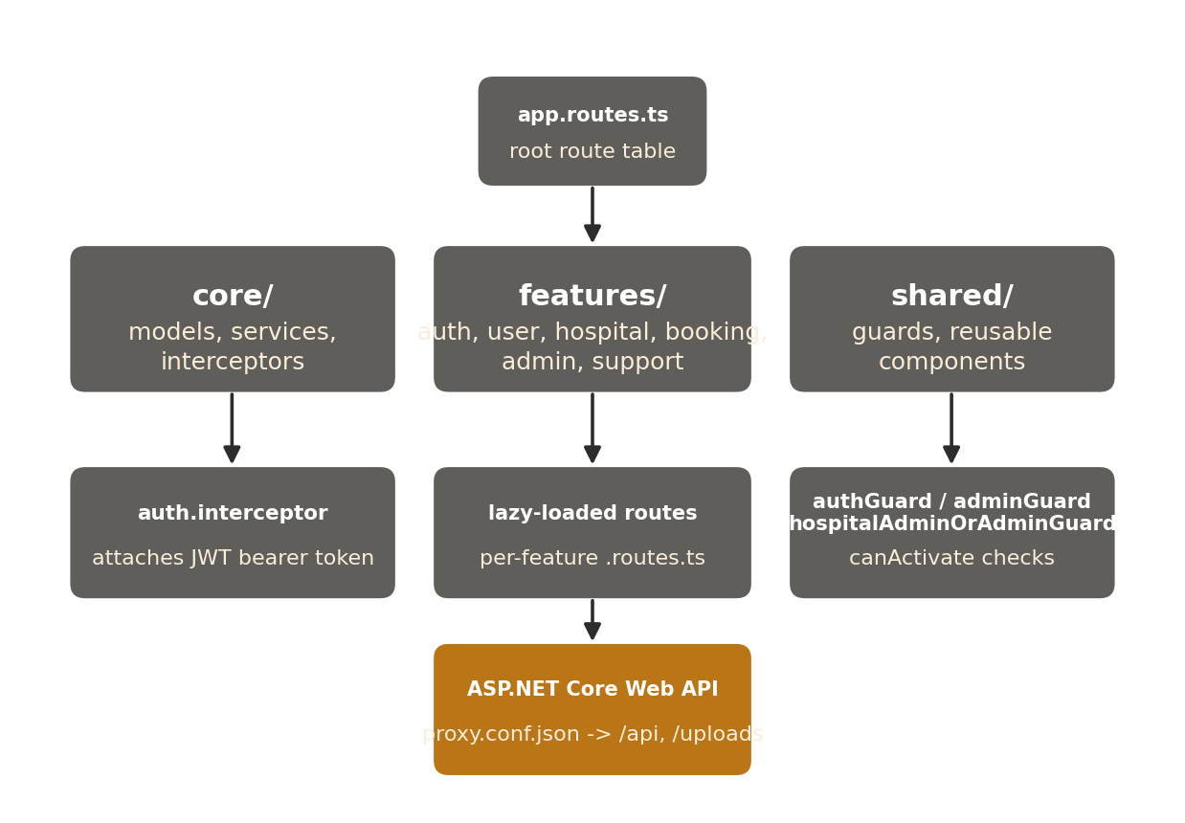
Figure 5. Frontend structure — core, features, and shared, talking to the API via the dev proxy.

13.2 core / features / shared
FOLDER | CONTENTS
core/models/ | TypeScript interfaces mirroring the backend DTOs — auth.model.ts, booking.model.ts, hospital.model.ts, notification.model.ts, role-mapping.model.ts, user.model.ts.
core/services/ | One Angular service per backend module (auth.service.ts, booking.service.ts, hospital.service.ts, notification.service.ts, role-mapping.service.ts, user.service.ts) plus certificate.service.ts for client-side certificate rendering/sharing. Each wraps HttpClient calls to its module's base route.
core/interceptors/ | auth.interceptor.ts — attaches the JWT bearer token to every outgoing request. See 13.4.
features/ | One folder per feature area: auth (login, register, forgot/reset password), user (profile), hospital (hospital-list), booking (my-bookings), admin (dashboard, users-management, bookings-management), support, about, account-reactivation, certificate-verify.
shared/guards/ | authGuard, adminGuard, hospitalAdminOrAdminGuard — route-level access control. See 13.3.
shared/components/ | Reused across features — audit-trail (renders any *AuditLogDto[] as a timeline), hospital-audit-trail, authorize-unregister-modal, confirm-action-modal, nav-bar, footer.

13.3 Route Guards
app.routes.ts applies guards per top-level route:
- authGuard — requires authService.isLoggedIn(); redirects to /auth/login otherwise. Applied to hospital, booking, user, admin, and support.
- adminGuard — requires authService.isAdmin() (reads the UserRole flag stored from login). Applied per-child inside admin.routes.ts, not at the top level — the admin/bookings child is reachable by any authenticated user (real authorization is enforced server-side, scoped to the caller's hospital-admin assignments), while admin/dashboard stays platform-admin-only.
- hospitalAdminOrAdminGuard — platform admins always pass; everyone else must hold an active hospital-admin role mapping, checked live against the server via RoleMappingService.isHospitalAdmin(userUid) (an Observable<boolean>, since this isn't encoded in the JWT and can't be read synchronously).
Every guard above is a UX convenience, not a security boundary — see Section 5.6. The same checks are independently re-enforced server-side.

13.4 Interceptors & the Auth Service
auth.interceptor.ts is a functional HttpInterceptorFn (the modern Angular interceptor style, replacing the older class-based HttpInterceptor pattern) that reads the token from AuthService.getToken() and, if present, clones the outgoing request with an Authorization: Bearer <token> header — every HTTP call made anywhere in the app automatically carries the caller's identity without each feature having to remember to add it.
AuthService uses Angular signal() state (isLoggedIn, currentUser, isHospitalAdmin) backed by localStorage (keys vaxtrack_token and vaxtrack_user). On construction, if a stored session is still valid (ExpiresAt in the future), it calls refreshRoleContext() to re-derive isHospitalAdmin from the server — this recovers hospital-admin status correctly across a full page refresh, which clears in-memory signal state but not localStorage.

13.5 Talking to the API — the Dev Proxy
During local development, the Angular CLI dev server proxies requests via proxy.conf.json:
{ "/api": { "target": "http://localhost:5119", "secure": false },
"/uploads": { "target": "http://localhost:5119", "secure": false } }
This lets the Angular app (http://localhost:4200) make same-origin-looking requests to /api/... and /uploads/..., which the dev server transparently forwards to the backend on port 5119, avoiding CORS friction during development even though the backend's own AllowAll CORS policy (Section 4.3) would permit direct cross-origin calls anyway.

14. Error Handling & Custom Exceptions

14.1 The Controller-Level Pattern
Every controller action in the codebase follows the same try/catch shape:
try {
var result = await _service.SomeAsync(...);
return Ok(result);
}
catch (UnauthorizedAccessException) { return Forbid(); }
catch (ArgumentException ex) { return BadRequest(new { message = ex.Message }); }
catch (Exception ex) {
_logger.LogError(ex, "{Controller}: {Action} - {Message}", ...);
return StatusCode(500, "An unexpected error occurred.");
}
This gives a consistent, predictable HTTP status mapping across all 67 endpoints:
EXCEPTION | MEANING | HTTP STATUS
UnauthorizedAccessException | Caller is authenticated but not permitted to act on this specific record (failed ownership or scoped-role check). | 403 Forbidden
ArgumentException | A business-rule validation failure surfaced with a client-readable message (e.g. a missing required reason on a disable action). | 400 Bad Request
Not authenticated at all / revoked / disabled token | Rejected by the JWT bearer middleware before reaching any controller — see Section 5.3. | 401 Unauthorized
AccountDisabledException | Thrown only from LoginAsync, after password verification. Caught specially in AuthController to return a structured error body. | 403 Forbidden (custom body)
Any other unhandled Exception | Logged with full context via Serilog, then a generic message is returned — internal detail is never leaked to the client. | 500 Internal Server Error

14.2 Custom Exception Example — AccountDisabledException
Vaxtrack.Exceptions.AccountDisabledException is the codebase's clearest example of using a custom exception type to carry structured information up through the layers, rather than a generic exception with just a message:
public class AccountDisabledException : Exception
{
public string? Reason { get; }
public AccountDisabledException(string? reason)
: base("Your account has been disabled.")
{
Reason = reason;
}
}
AuthService.LoginAsync throws this only after the supplied password has already been verified against the stored hash — see the timing-safety note in Section 6.3. AuthController.LoginAsync catches it specifically (before the generic catch (Exception)) and returns a structured 403 body the frontend can parse directly:
StatusCode(403, new { code = "ACCOUNT_DISABLED", message = ex.Message, reason = ex.Reason })
This code field is what the Angular account-reactivation feature checks for to decide whether to show its "your account is disabled — request reactivation" screen, rather than a generic login-failed message.

14.3 Why This Pattern, Not a Global Exception Filter
ASP.NET Core supports a global exception-handling middleware (or an IExceptionFilter) that would centralize this logic instead of repeating the try/catch shape in every action. The current codebase deliberately keeps it per-controller-action because each action's logging message includes its own controller and method name for easy log searching, and because a small number of actions (like login's AccountDisabledException) need genuinely different response shapes per exception type. A fresher extending this codebase should follow the existing per-action pattern for consistency rather than introducing a new cross-cutting mechanism without a team discussion.

15. Configuration & Environments
Configuration follows the standard ASP.NET Core layering: appsettings.json (base, checked into source with non-secret defaults) overlaid by appsettings.Development.json (local-only, gitignored where it holds real secrets) and environment variables in a deployed environment. Two custom configuration sections matter most:

15.1 JwtSettings
"JwtSettings": {
"Key": "<HMAC-SHA256 signing secret>",
"Issuer": "vaxtrack-api",
"Audience": "vaxtrack-client",
"ExpiryMinutes": 60
}
Bound to Models/JwtSettings.cs and registered as a singleton in Program.cs, so any service can have it injected. Key must be kept out of source control in a real deployment (environment variable or a secrets manager) — the value checked into appsettings.json in this repository is a local-development placeholder only.

15.2 SmtpSettings
"Smtp": {
"Host": "smtp.gmail.com",
"Port": 587,
"EnableSsl": true,
"FromEmail": "<sender address>",
"FromName": "VaxTrack",
"Username": "<sender address>",
"AppPassword": "<app-specific password>",
"FrontendResetPasswordUrl": "http://localhost:4200/auth/reset-password"
}
Bound to Models/SmtpSettings.cs and used by EmailService to send password-reset links. FrontendResetPasswordUrl is what makes the emailed link environment-aware — it must be updated per deployment (e.g. a staging or production frontend origin) rather than hard-coded.

15.3 Connection String
ConnectionStrings:DefaultConnection points EF Core at the SQL Server instance (vaxtrack_sqlserver database by convention). Section 4.3 covers how dotnet ef database update / the automatic MigrateAsync() call on startup apply the migration history from Section 12.4 against whatever this string points to.
This document deliberately does not reproduce actual secret values from the repository's configuration files — only the shape and purpose of each setting. Never commit a real JwtSettings:Key, database password, or SMTP app password to source control.

16. Non-Functional / Engineering Conventions

16.1 Logging (Serilog)
Configured at the very top of Program.cs, before the WebApplicationBuilder is even created, so startup failures are captured too. Two sinks are active simultaneously:
- Console — for local development visibility.
- Rolling file — a new file is created on every application start under Logs/vaxtrack-{yyyy-MM-dd_HH-mm-ss}.log (not a daily-rolling policy — a fresh file per run), which makes it trivial to isolate the log output of one specific run when debugging a reported issue.
Default minimum level is Debug, with Microsoft.* noise suppressed to Warning (except Microsoft.Hosting.Lifetime, kept at Information so startup/shutdown events are always visible). Every controller injects ILogger<TController> and logs on the generic-exception path with a consistent "{Controller}: {Action} - {Message}" template — grep-friendly by design.

16.2 API Versioning Convention
Every route is prefixed /api/vaxtrack/v1/ (Section 4.4). There is no live v2 of the API today — this is a forward-looking convention so a future breaking change can be introduced as /api/vaxtrack/v2/... alongside v1 without touching existing clients, rather than versioning the whole application (as the v1_backend / v2_backend repository split does at the project level).

16.3 Naming Conventions Observed in the Codebase
ELEMENT | CONVENTION | EXAMPLE
Async methods | *Async | CreateUserAsync
Service interfaces | I<Module>Service | IBookingService
Repository interfaces | I<Entity>Repository | IUserRoleMappingRepository
EF Core entities | <Entity>Model | HospitalModel
Request DTOs | <Action><Entity>RequestDto | CreateBookingRequestDto
Response / read DTOs | <Entity>ProfileDataDto / <Action>ResponseDto | UserProfileDataDto
Human-readable primary key | <Entity>Id | HospitalId
System GUID foreign key | <Entity>Uid | UserUid
Audit log tables | <Entity>AuditLogModel | BookingAuditLogModel

17. Glossary
Written for a reader who may not have encountered these terms before, regardless of years of experience — no assumed prior exposure to this codebase's own conventions.
TERM | DEFINITION
DTO (Data Transfer Object) | A plain class whose only job is to define the shape of data crossing a boundary (an HTTP request/response body). DTOs are kept separate from EF Core entity Models so the database schema can change without changing the public API contract, and so a request/response never accidentally exposes an internal-only field.
Repository pattern | A design pattern where all data-access code for one entity is grouped behind a single interface (e.g. IUserRepository), so the rest of the application never writes raw EF Core / SQL queries directly — it calls an intention-revealing method instead.
Dependency Injection (DI) | A pattern where a class declares what it needs (e.g. IUserService) via its constructor, and a framework-managed container (configured in Program.cs) supplies the actual implementation at runtime. This is what makes every layer swappable/mockable for testing.
JWT (JSON Web Token) | A compact, signed, self-contained token issued at login (Section 5) that proves who the caller is (and their role) without the server needing to look anything up — until VaxTrack's own revocation check, see 'blacklist' below.
HMAC-SHA256 | The specific signing algorithm used to sign VaxTrack's JWTs — a symmetric-key algorithm, meaning the same secret key both signs and verifies the token.
Token blacklist / revocation | A small server-side table (RevokedTokens) of token IDs that should be rejected even though they haven't naturally expired yet — VaxTrack's mechanism for supporting logout despite JWTs being stateless by default.
BCrypt | A password-hashing algorithm deliberately designed to be slow and to embed a random salt per hash, making stored password hashes resistant to offline brute-force even if the database is leaked.
EF Core (Entity Framework Core) | Microsoft's object-relational mapper (ORM) — lets the backend work with C# objects (Models) instead of writing raw SQL, and generates/applies schema changes via migrations.
Migration | A versioned, incremental description of a database schema change (e.g. "add this column"), generated by EF Core and applied in order. See Section 12.4 for VaxTrack's migration history.
Soft delete | Marking a record as deleted (an IsDeleted flag plus a timestamp) instead of physically removing the row — preserves history/audit trail and allows reversal, at the cost of every query needing to filter deleted rows explicitly.
Standalone component (Angular) | An Angular component that declares its own dependencies directly, without needing to belong to an NgModule — the pattern used throughout VaxTrack's v2 frontend.
Guard (Angular) | A function that controls whether a route is allowed to activate (e.g. authGuard blocks navigation to a protected route if the user isn't logged in). A UX convenience, not a security boundary — see Section 5.6.
Interceptor (Angular) | A function that can inspect or modify every outgoing HTTP request / incoming response — VaxTrack uses one to attach the JWT to every API call automatically.
Scoped role | A role that only grants elevated access within a specific context (e.g. one hospital), as opposed to a platform-wide role — see hospital-admin in Section 5.4.
Ownership check | A runtime check (in the service layer) that the record being accessed or modified actually belongs to the caller, independent of their role — see Section 5.5.
Audit trail | A permanent, append-only log of who did what to a specific record and when, distinct from the record's own current-state fields.
Idempotent / non-idempotent (context) | Not a term used verbatim in the codebase, but relevant when reading endpoint tables — note that most PUT-based lifecycle actions here are not strictly idempotent (calling Approve twice will fail the second time because the state has already changed).

18. Appendix — Diagram Index
FIGURE | TITLE | LOCATION
Figure 1 | High-level component view — client, application, and data tiers. | Section 2.1
Figure 2 | Backend layered architecture — Controller to Service to Repository to database. | Section 4.1
Figure 3 | Login through subsequent-request validation, including the revocation check. | Section 5.3
Figure 4 | Booking lifecycle data flow — book, approve/reject, dose administered, certificate. | Section 9.4
Figure 5 | Frontend structure — core, features, and shared, talking to the API via the dev proxy. | Section 13.1
All diagrams in this document follow the locked VaxTrack documentation style guide: rounded slate boxes, white bold titles, light-amber or light-gray subtitles of five words or fewer, thin slate-dark connectors, and amber reserved for a single emphasis element per diagram rather than routine connectors.

